Notes From the Class

Photos Website

<https://dribbble.com/shots/14324778-Password-Reset-Flow>

**Glossary - Intro to iOS**

Welcome to the iOS stack! The purpose of this glossary is to give you a quick reference for the terms used in this chapter. There will be a glossary at the beginning of each chapter. By the end of this chapter, you should have a working knowledge of all the terms on this list. Don't spend too much time reading about them now, just keep them in mind for later research as they are introduced.

**Swift** - A strongly typed, compiled language developed by Apple for iOS, macOS, watchOS, tvOS, and Linux.

**Xcode** - An integrated development environment (IDE) for macOS containing a suite of software development tools developed by Apple.

**Storyboard** - A file that stores screen layouts for an application, as well as the ways the screens interact with each other.

**Interface Builder**- A graphical user interface (GUI) within Xcode for editing storyboard files.

**Scene** - A single screen of an application and all of its subviews.

**View Controller** - A class that manages a scene, and the interactions between the interface and the underlying data.

**UIKit** - A framework that provides the required infrastructure for an iOS application.

**View** - Any component of a scene, including UIViews, UIButtons, UILabels, UIImages, etc.

**Attribute Inspector** - An area in Xcode that displays properties of the selected object and lets you configure them as needed.

**Auto Layout** - A constraint-based layout system that allows developers to create an adaptive interface that responds to changes in screen size and device orientation.

**Layout Constraint** - A relationship between two views, including position and size. Used by auto layout to calculate the size and location of each view.

**IBOutlet** - A reference within a view controller to a view in the managed scene.

**IBOutlet Collection** - A list of references within a view controller to multiple views in the managed scene.

**IBAction** - A function defined in a view controller, triggered by a specific event in the managed scene.

If you find a term that you think should be added to the glossary, use the report a mistake feature to request it.

# Think Different

(Video courtesy of [Nathan Hulls](https://www.youtube.com/watch?v=-z4NS2zdrZc))

# iOS Programming

**iOS is a mobile operating system developed by Apple**. This means that this course will primarily focus on applications that are running on iOS such as iPhone/iPad/Apple Watch applications. Although we will be primarily focused on building iPhone applications, building for other devices is very similar. OSX is an operating system for MacBooks and Macs. Fortunately, building OSX applications is not very different either.

IOS is a very large ecosystem. Unlike a web framework, an iOS application has very little required structure. You will have to first learn the tools in isolation and then you can begin to put them all together. It can be daunting learning something so vast, but remember that we are focusing on the 20% that we think will enable you to build 80% of the applications out there.

# What We Will Learn

* **Language**: The language that we will be using in this course will be Swift. Apple created Swift with the intention of replacing Objective-C. There is still a lot of Objective-C code out there, and many libraries are still written in it, but you can do everything in this course without learning it. Swift is a relatively new language and Apple is constantly iterating on it (we are currently on Swift 5), so be prepared for periodic updates to the language in the future.
* **Development environment**: If we want to develop anything for Apple, it is going to happen inside of Xcode. One of the benefits of having an all-in-one tool for building applications is that we will be spending less time configuring our environment and more time building our applications. However, Xcode is not a consumer-facing application. It is continuously being updated alongside the Swift language and there are often bugs that we will have to work around.
* **Frameworks**: There are tons of frameworks that Apple provides for us. Each framework could be a course in and of itself. We will be covering some of the frameworks but the goal by the end of the course is **having the ability to read the documentation and figure out how to use a framework of your choice**.
* **Patterns**: iOS programming might feel a little bit different at first with types, protocols, delegates, and extensions. It is important that we know these patterns, so we can collaborate with other Swift developers, and take full advantage of the frameworks Apple provides us.

## Prerequisites

* A solid understanding of the Swift Programming Language
* The latest version of Xcode (not the beta)

# Xcode

We need to know Xcode well. This is where we will spend all of our time building our iOS applications. Xcode is like photoshop for programming, it is a massive application and there is a lot of functionality that we don't need to learn when starting out. The main parts of Xcode are the **Toolbar**, **Navigator**, **Jump Bar**, **Utility Area**, **Editor Area,**and **Debug Area**.

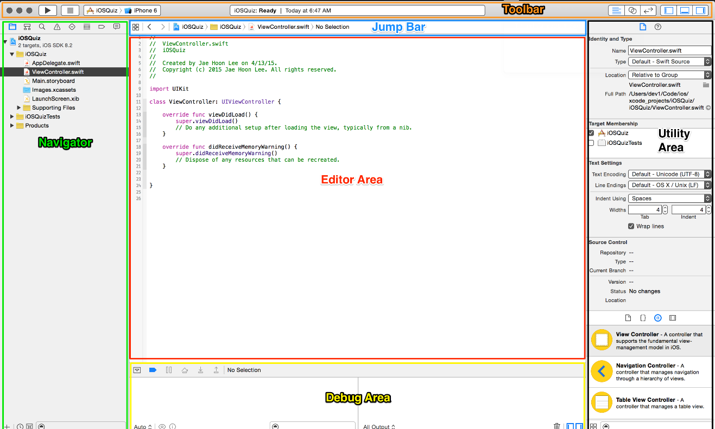

## Our First Application

**The best way to learn iOS is by building applications**. Let's go build our first iOS app and name it "iOSQuiz". **Go ahead and click create a new project**. Read more about the creation options below.



When we click "create a new project", a template selection window will show. Here we can choose a project template to use as a starting point for our application. We will be using the **Single View Application** for our first application. Then we will be directed to the project options sheet where we have to specify these fields:

* **Product Name**: This will be the name of our folder that holds the files to our application
* **Organization Name**: Xcode automatically inserts a copyright notice into every source code file you create
* **Organization Identifier**: Use reverse domain name notation (i.e. com.codingdojo)
* **Bundle Identifier**: Xcode combines the Product Name and Company Identifier to generate a unique Bundle Identifier
* **Language**: We will be using Swift.
* **Use Core Data**: Leave this unchecked for now. Core Data is one of the ways we can make data persist in our applications

## Toolbar



1. On the left side of the toolbar, we have iTunes-like button. **The play button starts building and running our application while the stop button stops it**.
2. We can also specify where to run our application to the right of the stop button. **We can either run the application on one of our devices or a host of simulators that Xcode provides for us**.
3. The box in the middle of our Xcode is called the activity view. **Activity View displays actions or processes that are currently happening**.
4. On the right of the Toolbar, we have three buttons for selecting what kind of editor we want to use and also three buttons that help us maintain the screen real estate on our screen. Currently, the standard editor is selected and it gives you a single pane dedicated to editing a file. **The Venn-diagram button next to the standard editor button splits the editor into two panes and Xcode will try to display two relevant files to you**. If you don't like what Xcode gives you, **you can always control which files to display on either screen with the Jump Bar (explained later in the tab)**. You can also select the version editor which is useful when we want to compare different versions of your app when we use source control. The final three buttons show and hide the Navigator, Debug area, and  Utility Area.



## Navigator

The Navigator is the left-hand side of your Xcode. Here we can seamlessly navigate through different aspects of our application. Here are the 8 Navigators available in the Navigator section. We can either click on the icons or we can use Command + 1 to access the Project Navigator (the first one), Command + 2 to access the Symbol Navigator, and so on.

* **Project Navigator**: List of files that are used in our project.
* **Symbol  Navigator**: Symbols are items that the compiler recognizes such as classes, enumerations, and structs.
* **Find Navigator**: We can find and replace any part of your application from one search bar.
* **Issue Navigator**: Whenever our application fails to build and run we can check out the errors or warnings here.
* **Test Navigator**: We can run our unit tests here.
* **Debug Navigator**: This is where we will go to debug our application. There are tools that keep track of memory, CPU, and the stack frame. A stack frame is a list of functions that have been called, in the order they were called. If you click on any aspect of the stack frame, we can observe the environment of our application right after that function was called.
* **Breakpoint Navigator**: We can make breakpoints in any part of our code so that we can look at the values in variables during that specific time in the life cycle. This is where we can look at all of our breakpoints from one place.
* **Log Navigator**: The Log Navigator keeps a history of recent build results and runs logs.



## Jump Bar



The jump bar is located at the top of the editor area.

1. We can access our recent files here, as well as the list of counterparts, superclasses, subclasses, and more.
2. The back arrow goes back one file and forward arrow undoes a back arrow. They work in the same way as our browsers.
3. This part of the jump bar allows us to navigate files without using the navigator. This area has a segmented pop-up that displays the hierarchical path to reach the selected file in the project. We can click on different parts of the segmented pop-up and XCode will navigate us there.

## Utility Area

1. 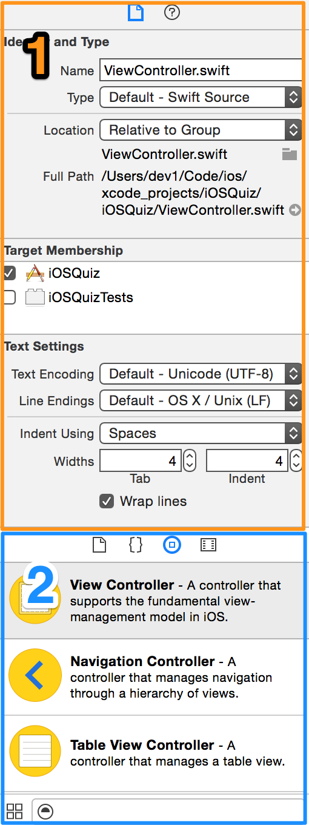The upper part of the Utility Area is a **context sensitive panel** which will give you a more detailed information of whatever is being displayed in the editor pane. You can also make changes here depending on what you have selected. For example, if you have a button selected in the editor area, you will be able to change some of its attributes such as size, text, background color in this panel. When a file such as ViewController.swift is selected, the utility area will have two different icons at the top, one that looks like a paper, and one with a question mark on it. The paper icon specifies the File inspector where we can view and manage metadata for a file such as its name, type, and path. The question icon specifies Quick Help which gives us details about a symbol. **This is a great place to learn more about specific API classes that we are unsure of.** When we select objects in the Interface Builder, we are given additional selectors. We will go over these more thoroughly later in the chapter.
2. (Xcode 9 only) The lower part of the Utility Area is where we can drag and drop different kinds of resources to our project. One of the primary usages of this part of the Utility Area is the Object Library which is what is selected in the picture to the right and discussed below.

## Object Library

The Object Library is where we can **drag and drop different kinds of resources to our project**. This is where we can drag and drop UI elements onto our Storyboard (discussed later). Things that can be dragged and dropped from this area are File templates, Code snippets, Objects, and Media files.

In Xcode 10.1 the Object Library is an overlay window, which can be moved and resized like Spotlight search. It dismisses once items are dragged, but holding the Option key before dragging will keep the library open for an additional drag. The library can be opened via a new toolbar button, the View > Libraries menu, or the ⇧⌘L keyboard shortcut. Content dynamically matches the active editor, so the same UI provides access to code snippets, Interface Builder, SpriteKit, or SceneKit items. The media library is available via a long press on the toolbar button, the View > Libraries menu, or the ⇧⌘M keyboard shortcut.

By default, once you select a resource to drag to your project, this window will close. However if you would like to **keep the window open as you work**, you can hold Option while clicking the Library button in the toolbar or by the ⇧⌥⌘L keyboard shortcut. When you open it this way, the window stays open, permanently, to use across projects until you explicitly close it with its Close button.

## Editor Area

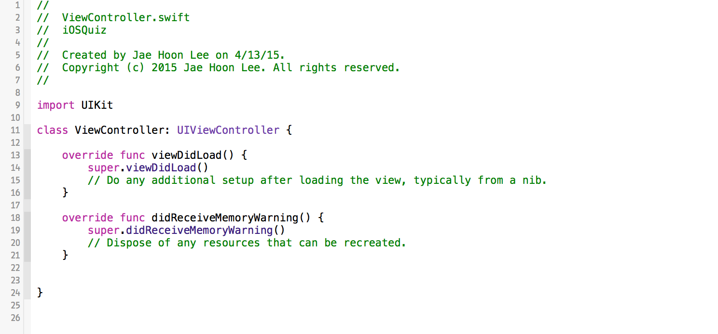

**We will either be working with Swift code or the Interface Builder in the Editor Area**. This is where most of our work will be done. We can also display different editors by choosing different editors in the Toolbar mentioned above. We will be going over the Interface Builder more in depth in the next tab as we build out the UI of our application.

## Debug Area

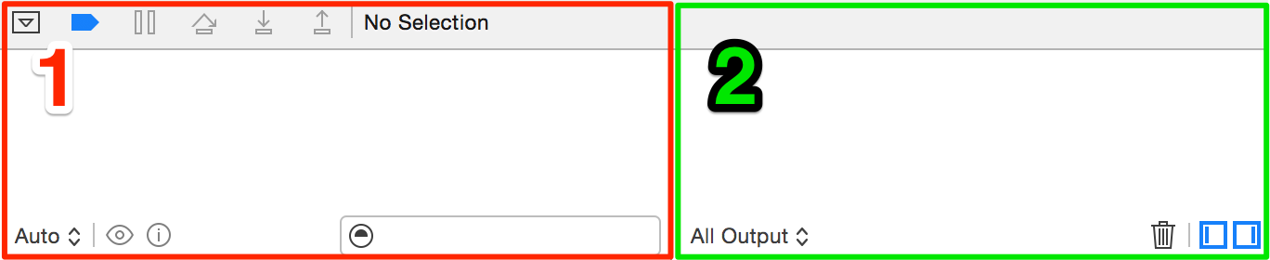

**The left side of the Debug Area is where we can closely observe values in specific variables during a breakpoint in our application. The right side of the Debug Area is where we can see any of our logs (print statements) that we put in our application. We log during different parts of the application so that we know that something is hooked up properly or not.  The two square buttons at the bottom right show and hide the left and right side respectively. If you don't see your logs printing out, check that the right button is selected.**

### Useful Hotkeys

* **Escape** - Show autocomplete list, very useful to see what methods you can call from a given type.
* **Command-R** - Run the application. I recommend checking the box in the popup dialog the first time.
* **Control-click-drag** / Right-click-drag - Make a connection (outlet or action) from a storyboard to a swift file.
* **Option-click** - Get more information about a variable, type, function, etc.
* **Command-click** - Perform actions eg. Jump to definition, fold a function, rename a variable, see the callers of a function.
* **Command-Shift-K** - Clean your project eg. recompile all files. This can solve strange errors when changes are not being reflected.
* **Command-K** - Clear the console

# UI Elements

Now that we know a bit more about the different sections of Xcode, let's start adding some basic UI Elements into our project. We will do this via the Xcode **Storyboard**.

## Storyboard / Interface Builder

Apple created Storyboards to make life easier for developers and describes it as **"a visual representation of the user interface for an iOS application"**. The beauty of the Storyboard is that it allows us to create a robust UI without having to dive into coding. This encourages the tried and true practice of building the UI first before hooking it up to code.

We will be designing our Storyboards using the **Interface Builder** in Xcode. The Interface Builder allows us to drag and drop scenes, buttons, text fields, and other objects onto the design canvas to create a functioning user interface. When a Storyboard file is selected, the **Interface Builder Editor** is shown in the Editor Area instead of the default Code Editor view.

To access the Storyboard and Interface Builder, click on the file named **Main.storyboard** on the Navigator.

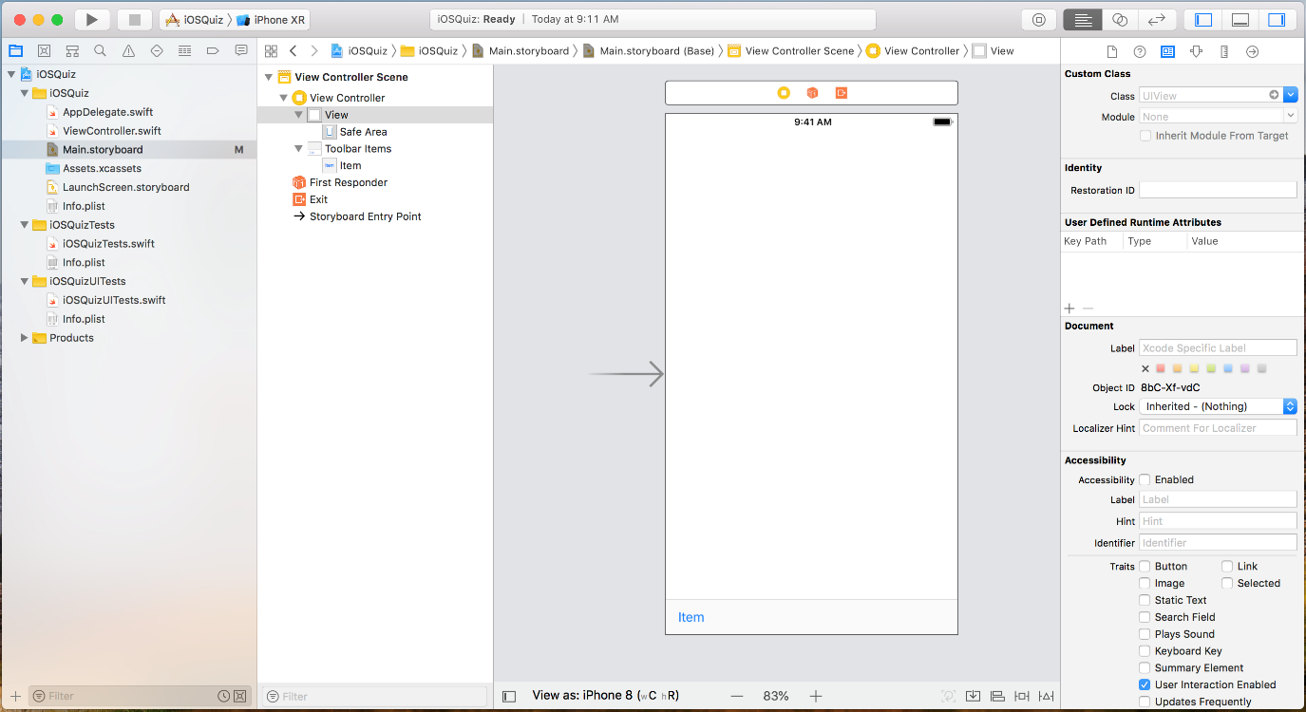

## Scenes

A **Scene** corresponds to a screen of an application, including all of its sub-views, and is managed by a **View Controller**. The Scene defines the layout and placement of different "views" or components on the page while the View Controller manages the Scene as and all the data for the different Views (components) that make up that Scene. In our storyboard, by default, we are given one scene. As we work to expand our projects we will often build out multiple scenes that link together via segues, but more on that later.

## Basic UI Elements

Let's add some UI Elements to our scene. We do this by dragging and dropping the element we want to add from **Object Library** into our Storyboard Scene. To access the Object Library, click the circular Object Library icon in the toolbar menu at the top (or Option-Click to leave it open). We will use the search field in the Object Library window to search for the elements we want to add.

The Object Library contains all of the different types of UI Elements that we can add to our project. Some of the most common ones we will be using include **Views, Labels, and Buttons**.

* **Views**: Not to be confused with View Controllers, **Views** are used to structure our UI and act as containers for other elements. They are the equivalent of **divs** in HTML.
* **Labels**: Labels are containers for text. We use labels when we want to add text to our Scene.
* **Buttons**: Buttons are special UI Elements that perform actions when interacted with. We can configure the behavior of buttons by creating "IBActions", which will be covered later in the chapter.

Now that we have the Object Library open, let's add a **Button** to our Scene.

1. Type "button" into the Object Library's search bar. The first element in the list should now be the **Button** object.
2. Drag and drop the Button object from the Object Library to the Scene in the Storyboard.
3. Snap the edges of the button to the blue dashed lines on the top, left, and right of the Scene.

Notice that when we drag the object over the Storyboard Scene, blue dashed lines appear and the elements snap into place when near those lines. These blue guidelines are Apple's suggested placement for UI Elements with regards to the edges of the screen and can come in handy when placing new objects.

After the element is placed, we can resize or move the object using the resizing boxes. We will learn more about formatting layouts later. For now, let's snap the button to the blue lines on edges of the Scene.

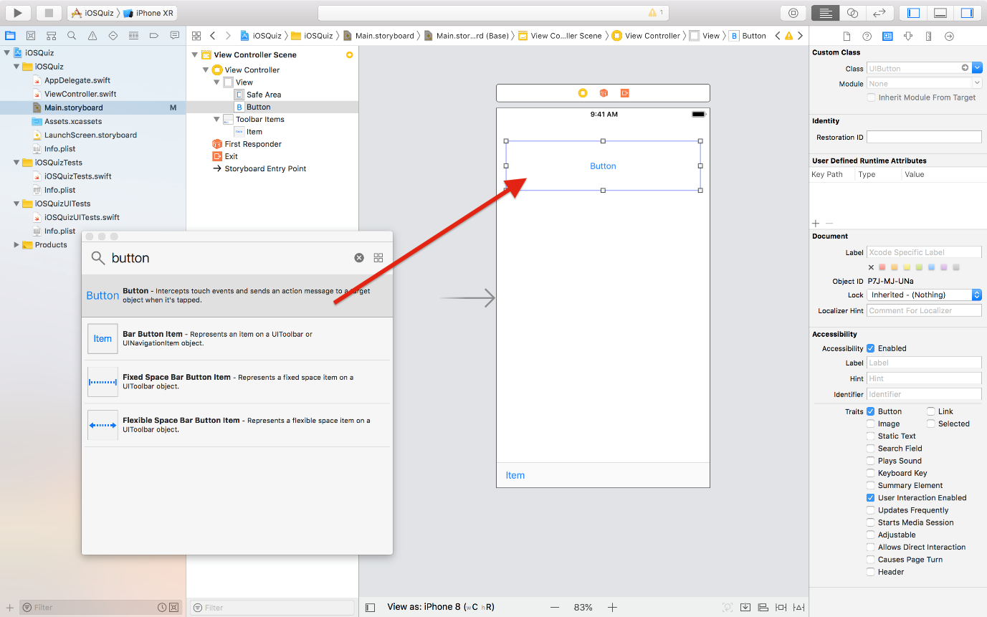

Great! We just added a button to our Scene. We can add other UI Elements to our Storyboard in the same way, by dragging and dropping it from the Object Library into our Storyboard Scene. Now that we have UI elements in our Scene, **let's take a look at how to style UI Elements using the Attribute Inspector**.

**Attribute Inspector**

Once we add UI Elements in our Storyboard Scene they will appear in the object dropdown menu on the left side of the Storyboard panel. When an element is selected, we can change it's properties via the Attribute Inspector located in the Utility Area on the right panel of Xcode.

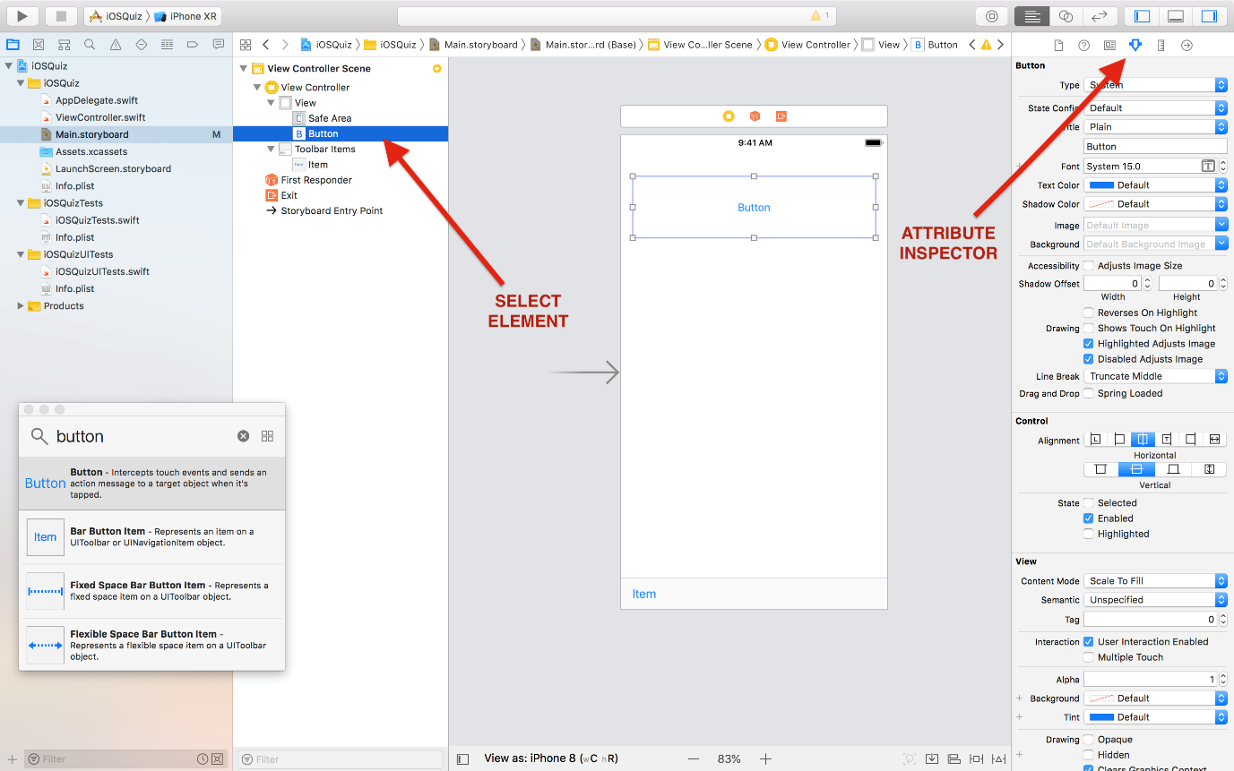

Using the Attribute Inspector, we can customize a number of properties, including the background color, text color and title of our element. Let's change some attributes for our Button object.

1. Change the **Title** from "Button" to "Why did the programmer quit his job?".
2. Change the **Background** to blue. (You might have to scroll down to find the background color field)
3. Change the **Text Color** to white.

After these changes, your button should look like the image below.

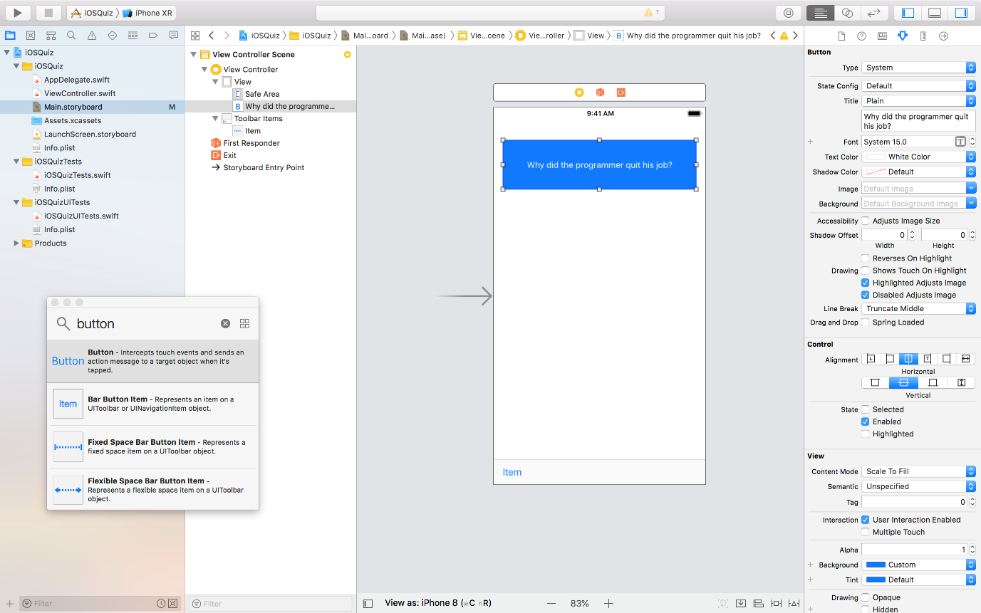

The Attribute Inspector allows us customize properties of UI Elements without a single line of code. However, it's important to note that everything we do can via the Attribute Inspector, we can also do programmatically using Swift. We will learn more about how to programmatically access object attributes later on in this chapter. **For now, let's delete the button we created and keep working on the iOSQuiz.**

# User Interface First

**Xcode is designed so that we build the user interface first. Always design how you want the UI to look and then figure out how to make it work with the code.**Xcode is perfectly made for this workflow. **We can build our UI by dragging and dropping things such as Labels and Buttons from our Object library**. The reason why we build the UI first is that after we build the UI **we will be able to have a better understanding of our application and, therefore, waste less time figuring out how to make it work.**

## Building our Interface

You will see two .storyboard files in the sidebar. LaunchScreen.storyboard is displayed as the application launches, we generally put a logo here and nothing more. Main.storyboard is where the application will start, this file is specified in the info.plist. If you change the name of Main.storyboard or want to start at a different .storyboard you must change the value of "Main storyboard file base name" in the info.plist.

Click on Main.storyboard and place a Label in the center-top of the square view. Double click on the Label and replace the text inside with "What is the first step to iOS development?" Sometimes developers will design UI on a square screen (like the examples below). This is because iOS apps run on many different devices. **We don't know what kind of products Apple will release, and we already have multitudes of Apple products with varying screen sizes. Designing our UI in a square canvas helps us think about layout in terms of constraints rather than exact placement.**We will be placing constraints using Auto Layout in the next tab.



**When we are initially placing View objects into the Storyboard, try to use the guided blue lines as much as possible. This is XCode helping us make better UI.**Next, we are going to drag two buttons out of the Object Library. We can drag and drop the buttons just like we did with the label. One button will be to the left with the text "Answer" and the other button will be to the right with the text "Next."



Now we are going to drag and drop another Label in the center of the screen with the following text: "Create the user interface. As we create the UI, we will get a better understanding of our application. Then we breathe life into our application." With default settings, our Label will go off the screen as it tries to fit all of the text in one line. First, let's resize the label so that it's as wide as the screen. Next, click on the Label and then go to the Utility Area, select the Attributes Inspector and change the number of lines to be 0. Once it is set to 0, XCode will wrap the text around once it hits the width of the containing label. Let's increase the height of the label so we can see all the text. We can also set the text at the top of the Attributes Inspector instead of double clicking on the label.



We are done with building our UI! Kind of. Go ahead and press Command + R to build and run your application. **The results might not be what you were expecting. To fix this, we have to add Auto Layout constraints.**

# Auto Layout

First, we will demonstrate how Auto Layout can be used. Afterward, we are going to apply Auto Layout again to our iOSQuiz application. **The best way to learn Auto Layout is to keep practicing**. Some people say Auto Layout is the **hardest part of iOS programming and it isn't uncommon to find yourselves spending hours laying out your application and end up deleting all of the constraints and starting over.** You will find plenty of developer frustration over Auto Layout on the Web and it is because**it really pushes developers to think about design differently**. Auto Layout has gotten better over the years and it is a crucial skill for us to master if we want to create one layout that will work across devices and orientations.

<https://player.vimeo.com/video/142831211>

Go to  [Auto Layout Guide](https://developer.apple.com/library/content/documentation/UserExperience/Conceptual/AutolayoutPG/) and read the Introduction, Auto Layout Concepts, and Working with Constraints in Interface Builder. **At first, it may seem like Auto Layout is slowing you down**. It takes time thinking about design in this way. We set specific constraints in our View objects in our storyboard**so that they would know how to adapt depending on screen size and orientations (portrait vs. landscape).** Auto Layout is more important now as Apple has moved on to creating products in all shapes and sizes.

Imagine the world without Auto Layout. We would have to create a different layout for all devices and a different one for each orientation. Can you imagine creating a different layout every time a new Apple product is released? **As developers, we need to accept the uncertainty of the various future products Apple will introduce and make sure that the applications that we make can adapt to these new environments**. We set constraints on our View objects so that they know how to adapt to its environment.

When we ran our current application, it does not look at all like how we laid it out in the storyboard. And why is our scene so square?! Apple wants us to think about design differently; instead of placing things based on fixed screen width, we create rules for our view objects to adapt to any given scenario.

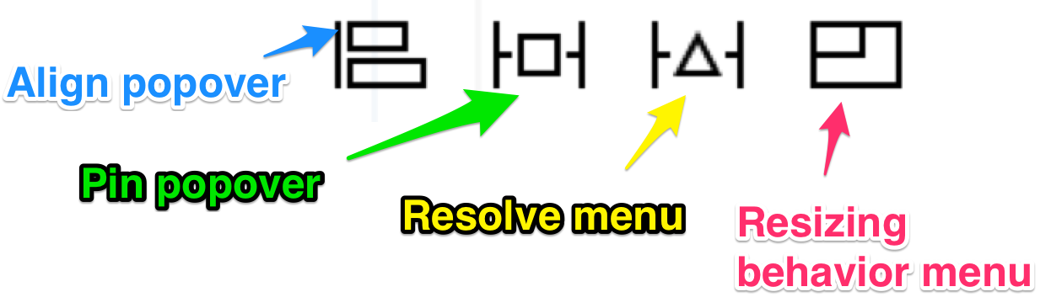

There are 4 tools available to use in Auto Layout

* Align popover
* Pin popover
* Resolve menu
* Resizing Behavior menu

## Step 1 [gif-walkthrough](http://i.imgur.com/caHj95B.gif)

We will be setting constraints on our question label first. **Constraints can either be set between two different View Objects or onto itself**. Our goal is to set just enough constraints so that Xcode will know how to layout our application no matter the screen size or orientation. If we add too much or too little, Xcode will complain to us. **We are going to set the first constraint onto the question label itself**. We are going to give Horizontal Center in Container constraint to our question label by first clicking on the label, adding the constraint in our **Align popover** menu.

After we place this constraint, Xcode will complain to us by giving us a red border on the top and bottom. **This is Xcode telling us that our layout is vertically ambiguous: there's more than one possible layout given the constraints**. This is because Xcode can place the question label anywhere as long as it is horizontally centered. We are going to set three more constraints. We are going to "pin" the question label to the top, left, and right using the third icon with a measurement of 0 in our **Pin popover**menu. **In the Auto Layout video, we did these steps by control dragging from one object to the object we wanted to create a constraint with. This is just an alternate way and some developers prefer just using the Pin popover menu because it is less error prone when our layout is very complicated.** Since we have "Constrain to margin" selected, question label will go as close as the recommended margin. Then we will set our Lines attribute of our question label to 0 so that the label can move on to the next line if the question is long. **If you are getting warnings regarding frames, click on Resolve menu and click update frames. What the warning is telling you is that given the current constraints, the View Objects might not be placed where you might expect.**

## Step 2: [gif-walkthrough](http://i.imgur.com/Ue9zVPB.gif)

Now let's add constraints to our buttons. First, we want to pin the Answer button with a left value of 0 and top value of Standard Value in our **Pin popover** menu. **Standard Value is the same as 8, but try using Standard Value as much as possible**.**It is important to note that the constraint to the left is different from the constraint to the top in this example.** The first constraint is a **relationship between the Answer button and the super view**. We want the Answer button to be 0 points away from the super view that is the parent view of all subviews. On the other hand, the second constraint is a **relationship between the Answer button and the question label**. We want to be Standard Value away. We can observe and even choose which View objects we want to have a relationship in the same drop-down menu in the Pin Popover.

## Step 3: [gif-walkthrough](http://i.imgur.com/lYwbe3i.gif)

Next, we need to make sure our Next button is laid out properly. We are going to do this by creating a relationship between Answer button and Next button by giving them a baseline constraint in our **Align popover** menu. This means that their baselines will always match up. Now we could pin the Next button to the top and to the right, but we only have to pin it to the right in this case. This is because since the Answer button is already pinned to the top, and has to have matching baselines with Next, Xcode has enough information to place the Next button.

## Step 4: [gif-walkthrough](http://i.imgur.com/TAWlhu1.gif)

Now we just have to place the answer label properly. We are going to give 2 constraints to itself by giving it the Horizontal and Vertical Center to Container. This is creating a relationship between the answer label and the super view. Then we are going to pin the left and the right with a value of 0. Now Xcode has enough information to layout our UI.

## Strategies

**Pick one of the top corners and work towards the opposite corner.**Add constraints to the top left most view and move to the bottom right. If we jump around we are bound to overlook something. **Auto Layout is a delicate process and there will be many times where it might just be easier to start all over.**

We can either run and build your app each time but it is more convenient to have a preview pane open so that you can see our changes in real time. Try to avoid reset to suggested constraints.

After we have set all of the constraints open up the size inspector to for each View object and see if you can find any numbers that are not 0 or a Standard Value. Try to use these as much as possible.  If we are doing something other than the standard we should think very carefully if that is really needed.